**Building a Basic RestFul API in Python with Flask :**

* Install python We can use Flask or Django.
* **$** virtualenv venv (this will create virtual envirnment)

**$** venv\Scripts\activate.bat (for windows) (this step will activate envirnment)

**$** pip install flask flask-jsonpify flask-sqlalchemy flask-restful

**$** pip freeze

* Install db from this site for sqlite3.exe <https://www.sqlite.org/download.html>
* From your windows command prompt, you can start sqlite3 either with:

cd c:\Stuff

sqlite3.exe

* Now run server.py

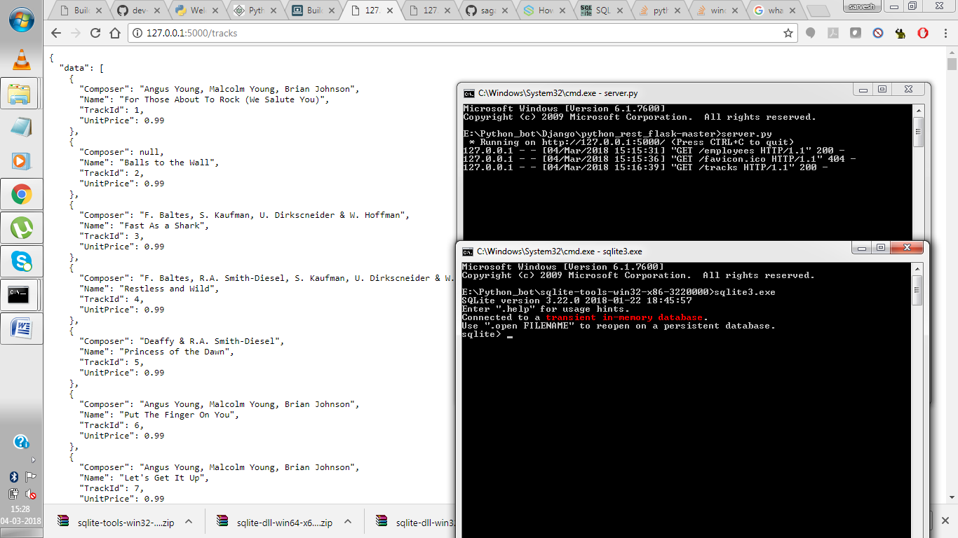

* This server.py contains all kind of REST request like GET, POST, etc.
* **Try** <http://127.0.0.1:5002/employees> , <http://127.0.0.1:5002/tracks>

ENJOY!!!!!!!!!!!!!!!!!!!!!!!!!!!!!!!!

Author: Sarvesh Yadav